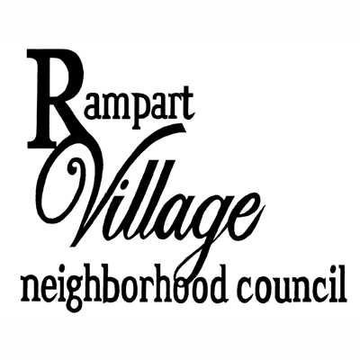 | Public Safety, Housing & Transportation Committee Joint Meeting with  Homelessness Solutions Committee  D.J. Bibingkahan  190 S. Vermont Ave, LA, CA 90189  Saturday, October 13, 2019, 1:00 P.M.  Agenda  Lara Morrison, Co-Chair | Nathaniel Singer, Co-Chair  Philip Armstrong | Lorelle Lynch | TBD

1. Call to Order, Roll Call, and Reading of each Committee’s Mission Statement
2. Public Comment on Non-Agenda Items (2 minutes per speaker) (10 Minutes)
3. Discussion and Possible Action on the following Motions & Resolutions: (30 Minutes)
A. How can the two committees work together?
B. Updates on relevant activities.
C. Selection of committee roles (including producing minutes).
D. Set agenda for next meeting.
4. Stakeholder Suggested Future PSHT and Homelessness Solutions Committee Agenda Items
(10 minutes)
5. Committee Member Suggested Future PSHT Committee and Homelessness Agenda Items
6. Announcements
7. Adjournment

Time allocations for agenda items are approximate and may be shortened or lengthened at the discretion of the presiding officer. The presiding officer may take items out of order. All items on the agenda are possible action items and subject to a Community Impact Statement (CIS) filing to the City Clerk’s Office. If you would like a copy of any record related to an item on the agenda, please contact the RVNC President, Rachael Rose Luckey, at 323.799.8772 or email: RampartVillage@gmail.com.

PUBLIC ACCESS OF RECORDS – In compliance with Government Code section 54957.5, non-exempt writings that are distributed to a majority or all of the board in advance of a meeting may be viewed at our website: rvnc.org/rvncmeetingdocumentation or at the scheduled meeting. In addition, if you would like a copy of any record related to an item on the agenda, please contact Rachael Rose Luckey at RampartVillage@gmail.com

Comments from the public on Agenda items will be heard only when the respective item is being considered. Comments from the public on other matters not appearing on the Agenda that is within the Board’s subject matter jurisdiction will be heard during the Public Comment period. Public comment is limited to 2 minutes per speaker, unless waived by the presiding officer of the Board. Agenda is posted for public review at: 1) LA Eco-Village, 117 Bimini Pl, 90004; 2) RVNC Bulletin Board, Suit #236, 155 N. Occidental Blvd, 90026; 3) www.rvnc.org; and 4) www.EmpowerLA.org.

As a covered entity under Title II of the Americans with Disabilities Act, the City of Los Angeles does not discriminate on the basis of disability and upon request will provide reasonable accommodation to ensure equal access to its programs, services, and activities. Sign language interpreters, assisted listening devices, or other auxiliary aids and/or services may be provided upon request. To ensure availability of services, please make your request at least 3 business days (72 hrs) prior to the meeting by contacting or send an e-mail that states the accommodations that you are requesting to the RVNC President, Rachael Rose Luckey, at 323.799.8772 or email: RampartVillage@gmail.com, or you may contact the Department of Neighborhood Empowerment Support at 213.978.1551 or e-mail NCSupport@lacity.org.

SI REQUIERE SERVICIOS DE TRADUCCION, FAVOR DE NOTIFICAR A LA OFICINA 3 DÍAS DE TRABAJO (72 horas) ANTES DEL EVENTO. Por favor envíe solicitudes a: RampartVillage@gmail.com o llamar 213.568.3086

